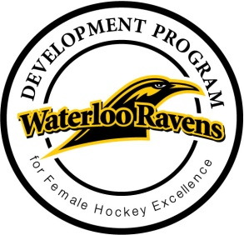
Waterloo Ravens Development Programs

Volunteer Registration Form

Send completed form to: dwayne@waterlooravens.com
First Name:
Last Name:
Email:
Cell Phone/Text:
Preferred volunteer opportunity or opportunities. <check those that interest you>
Learn to Skate – most sessions Sundays 3p-4p
Rookie Ravens - most sessions Sundays 4p-5p
Rookie Ravens Plus - most sessions Sundays 4p-5p & Thursdays 5p-6p
Ravens Clinics (Tuesday Evenings) – Goalie Clinics *Shooters required
Skating Experience/Current Team (if applicable):

Additional Comments:

Please note for adult volunteers (Ages 18+) Vulnerable Sector Screening (Police Check) and Respect in Sport completion are required. Reimbursement available from Waterloo Ravens organization on successful completion. Details on website – Volunteer.

